Controlled Access Protocol - Token Passing

1. A station is authorized to send data when it receives a special frame called a token
2. Here there is no master node
3. A small, special-purpose frame known as a token is exchanged among the nodes in some fixed order
4. When a node receives a token, it holds onto the taken only if it has some frames to transmit; otherwise, it immediately forwards the taken to the next node.
5. If a node does have frames to transmit when it receives the token, it sends up to a maximum number of frames and forwards the token to the next node.
6. Token passing is decentralized and highly efficient. But it has problems as well:
   1. For example: The failure of one node can crash the entire channel. Or if a node accidentally neglects to release the token, then some recovery procedure must be invoked to get the token back in circulation.

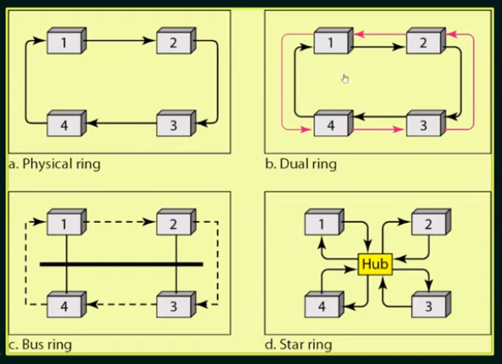

1. Performance:
   1. 